TECHNICAL UNIVERSITY OF KOSICE
DEPARTMENT OF COMPUTERS AND INFORMATICS

Cloud technologies fundamentals
Docker flask mongo website documentation

2026 Danylo Cherednychenko
Contents
1. Conditions for deploying and launching the application 3
2. Description of the application 3
3. Virtual networks and named volumes used by the application 3
4. Container configuration 3
5. List of containers used 4
6. Instructions to prepare, launch, pause, and delete the application 4
7. Instructions for viewing the application in a web browser 5
8. List of used resources 6
9. Use of artificial intelligence and list of used agents. 6

Conditions for deploying and launching the application
To run this application, Docker Desktop must be installed and running. Docker Compose is also required; Docker Desktop includes Docker Compose, which Docker documents use as the recommended way to get it on Windows, macOS, and Linux. A modern web browser is needed to open the web interface after startup. Internet access may be required the first time the project is launched so Docker can download the base images used by the application.

Description of the application
This application is a CRUD(Create, Read, Update, Delete) web system for managing a list of products. It provides a browser-based interface where the user can create, view, edit, and delete product records. The web layer is built with Flask, which is a lightweight Python web framework, and the application stores product data in MongoDB using PyMongo, the official MongoDB driver for Python. The mongo database name is appdb and the collection is called products.

Virtual networks and named volumes used by the application
The application uses a Docker network so that the web container and the MongoDB container can communicate with each other internally by service name. Docker Compose is specifically designed for defining and running multi-container applications, including services, networks, and volumes. The project also uses a named Docker volume for MongoDB data storage. This volume keeps database data persistent, so stopping or recreating containers does not automatically erase the stored product records unless the volume is explicitly removed.

Container configuration
The project contains two containerized services. The database service uses the official MongoDB container image and is configured with initialization credentials through environment variables. The web service is built from the local project files using a Dockerfile and runs the Flask application. The web container publishes the application port to the host machine so the browser can access it.
Both containers can be configured with restart policies so they restart automatically after failures or Docker restarts, depending on the selected policy in the Compose configuration. Docker Compose supports this style of multi-service configuration through the Compose file.

List of containers used
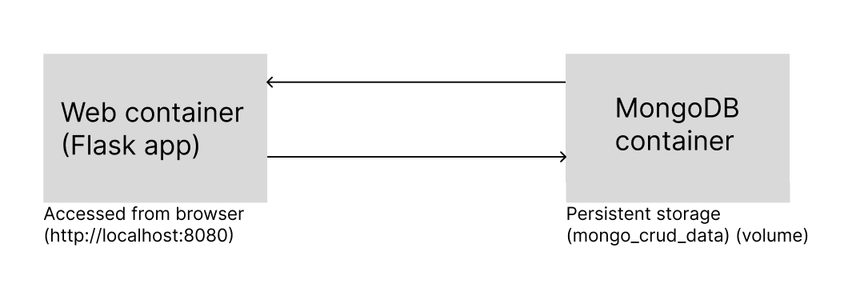
mongo-crud-db
This container runs the MongoDB database service and stores all product data used by the application. It uses the MongoDB container image and writes persistent data to a named volume.
The application connects to the database using the following configuration:
- MONGO_URI: mongodb://admin:admin123@mongo:27017/
Defines the connection string used to access MongoDB.
  - admin:admin123 → authentication credentials
  - mongo → hostname (Docker service name)
  - 27017 → default MongoDB port
- MONGO_DB_NAME: appdb
Specifies the name of the database used by the application.
- MONGO_COLLECTION_NAME: products
Defines the collection where product data is stored.

mongo-crud-web
This container runs the Flask web application. It receives HTTP requests from the browser, performs CRUD operations, and communicates with the MongoDB container through the Docker network using PyMongo.

Instructions to prepare, launch, pause, and delete the application
- prepare-app.sh
This bash script prepares the application, run the preparation script that builds the images and ensures the required Docker resources such as the network and volume are available.
- start-app.sh
This bash script launches the application, run the startup script, which starts the web and database services.
- stop-app.s
This bash script pauses the application without losing data, run the stop script, which stops the containers but does not remove the named volume.
- remove-app.sh
This bash script deletes the application completely, including containers, network, and stored database data, run the removal script. Docker Compose also provides equivalent lifecycle commands such as up, start, stop, and down.

Instructions for viewing the application in a web browser
After the application has been started successfully, it can be opened in a web browser using the host port mapped in docker-compose.yml
The current configuration maps host port 8080 to the web container port, the application is available at http://localhost:8080. If the host-side port mapping is changed, the application should be opened using the new host port instead.
The following screenshots show a web application running in Docker that allows users to create, view, update, and delete products.
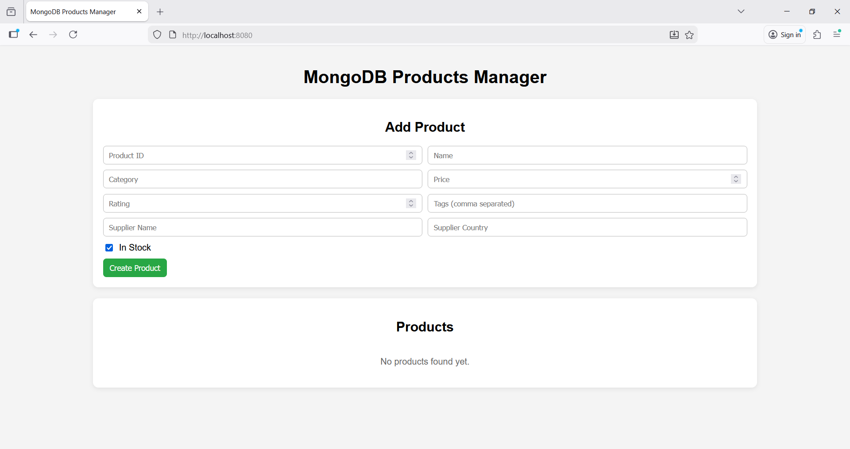

List of used resources
- Docker Compose documentation — information about defining and running multi-container applications. https://docs.docker.com/compose/?utm
- Compose file reference — reference for services, networks, volumes, environment variables, and port mappings used in docker-compose.yml. https://docs.docker.com/reference/compose-file/?utm
- Docker Compose CLI reference — command reference for docker compose up, start, stop, down, logs, and related commands. https://docs.docker.com/reference/cli/docker/compose/?utm_
- Flask documentation — reference for the Python web framework used to build the website. https://flask.palletsprojects.com/?utm_
- Flask quickstart — introduction to creating routes, rendering templates, and running a Flask app. https://flask.palletsprojects.com/en/stable/quickstart/?utm_
- Flask configuration documentation — reference for app configuration and environment-driven settings. https://flask.palletsprojects.com/en/stable/config/?utm_
- MongoDB documentation — general documentation for the database used by the application. https://www.mongodb.com/docs/?utm_
- PyMongo driver documentation — reference for connecting Python code to MongoDB and performing database operations. https://www.mongodb.com/docs/languages/python/pymongo-driver/current/?utm_source=chatgpt.com
- PyMongo get started guide — practical guide for establishing MongoDB connections from Python. https://www.mongodb.com/docs/languages/python/pymongo-driver/current/get-started/?utm_
- MongoDB Docker image documentation — reference for running MongoDB in Docker containers and connecting from other containers. https://hub.docker.com/_/mongo?utm_

Use of artificial intelligence and list of used agents.
For this project I have used ChatPGT to write comments in code that explain what that portion of code does, I have done this because it is good to have comments in your code and using an LLM to write those saves time. https://chatgpt.com

